MONACO – HOME TO THE RICH N FAMOUS

Monaco and, in particular, the principal district of Monte Carlo, has drawn the rich and famous to its sunny Mediterranean shores since the 19th century - when its grand casino was built.

At just under two square kilometres, the Principality of Monaco is the second smallest independent state in the world after the Holy See. Broadly it consists of the pretty old fortified quarter of Monaco-Ville, an attractive harbour area, and the district of Monte Carlo.

Monaco is an ideal destination for a short break, or as part of a longer trip round the South of France, combining several historical sites of interest, such as the cathedral and the Prince's Palace with a beautifully rugged coastline, attractive beaches, a warm climate and plenty of opportunities to rub shoulders with the glitterati.

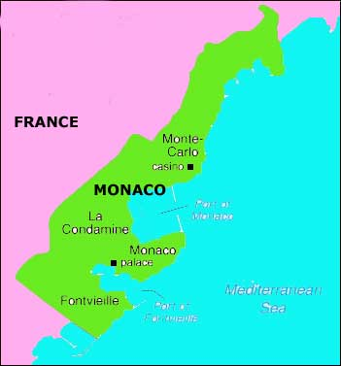

LOCATION :
A sovereign and independent state, the Principality of Monaco has borders on its landward side with several communes of the French Department of the Alpes-Maritimes; from west to east. Seawards, Monaco faces the Mediterranean Sea.
The Principality has only one commune, Monaco, whose limits are the same as those of the state.

VISA REQUIREMENTS :
1) Valid Passport with minimum 6 months validity from date of travel
2) One Visa Application form Duly filled in Capital letter and Signed as per Passport ( Photocopy of the form allowed )
3) Two Recent Passport Size color Photographs with white background with matt finish.size has to be 35 *45 mm with 80 percent of the face should be seen.
4) Covering Letter from Indian Company Stating Applicants Name, Designation, Purpose
Duration of Visit
5) Invitation from France Stating Applicants Name, Designation, Purpose
Duration of Visit
6) Return Confirmed Air Ticket for Duration of stay with one copy
7) Foreign Exchange Duly Endorsed / Valid International Credit Card Copy
8) Last Three years Income Tax Returns Copies (photocopies)
9) Latest three Months Saving Bank Statement (photocopies)
10) Medical Insurance For Duration stay with one copy
11) Salary Certificate or Appointment Letter from Indian Company
12) The invite, covering letter, insurance and the ticket dates must be matching

Effective 13th November 2006 every applicant (6 years and above) is required to complete the process of finger-printing at the office of the Consulate General of France. New Visa Application Procedure at the Consulate General of France in Mumbai
Effective 13th November 2006 every applicant (6 years and above) is required to complete the process of finger-printing at the office of the Consulate General of France.

{Please note above are the standard documents that the Consulate usually ask for, in case they require any more documents or clarifications we shall let you know. Please bear with us as we have no control on the requirements for the Visas.}

HOW TO GET THERE :
Nice - Cote d’ Azur International Airport is 33 kms. From Monaco.

GETTING AROUND :
Train :
The Monaco-Monte Carlo (SNCF) railway station is a stop for many international trains. Destinations include Nice (20 minutes), Cannes (1 hour 15 minutes) and Menton (15 minutes). Trains depart at least every hour with more at peak times. Almost all long distance routes including Marseille (EUR31.70, 4 hours 20 minutes) and Paris (EUR115.30, 6 hours 30 minutes) involve a change at Nice rail station.

Bus :
Rapides Cote d'Azur operates buses daily from designated stops along Blvd Charles III and Blvd Rainier III to Nice Airport from 06h05 until 19h55. Buses run from 09h00 until 21h15 on the return leg from Nice Airport to Monaco.

DISTANCES :
The following table provides approximate driving distances between selected cities in the region. Kilometres in the lower left of the table, miles in the upper right.
 | Nic | Mon | Can | Mar | Aix | Gen | Par | Tou
Nice | • | 10 | 21 | 127 | 109 | 119 | 576 | 346
Monte Carlo | 16 | • | 34 | 140 | 122 | 112 | 589 | 359
Cannes | 33 | 54 | • | 110 | 92 | 140 | 560 | 329
Marseilles | 204 | 225 | 178 | • | 19 | 246 | 481 | 250
Aix-en-Provence | 175 | 196 | 149 | 30 | • | 228 | 470 | 239
Genoa | 192 | 180 | 226 | 396 | 368 | • | 568 | 465
Paris | 928 | 948 | 901 | 774 | 756 | 914 | • | 507
Toulouse | 557 | 577 | 530 | 403 | 385 | 749 | 817 | •

CURRENCY :
The Euro is the official currency of Monaco. Euro 1 = 100 cents. The Euro sign is €.

BUISNESS :
Bank hours are 9:00AM to 12:00PM and 2:00PM to 4:00PM. Banks are closed on weekends and national holidays except for “Credit Foncier de Monaco” near the Casino, which is open daily for 12:00PM to 11:00PM including Sundays and holidays.

The majority of stores in the principality are open daily, 09h00-12h00 and 14h00-19h00. Many of the tourist or service outlets remain open all day.

CLIMATE :
Situated in the heart of Mediterranean Europe, the Principality of Monaco enjoys a particularly mild climate, with more than 300 days of sunshine per year. In winter, temperatures average between 9-15 degrees with sunny days and cool nights. Most summers are between 20-26 degrees with hot spells for a week or so in July and August. Sea breezes cool down the evenings. One of the loveliest times to be in Monaco is Fall. With temperatures between 15-20 degrees, people are still sun tanning on the beach until mid-October

CLOTHING :
Apart from on the beaches and bathing areas, it is forbidden to walk about in swimsuits, stripped to the waist or bare foot. Appropriate clothing must be worn in all public establishments and in particular in religious buildings. For receptions or the casino, a jacket and tie should be worn. For gala events, black tie (dinner jacket) is required.

TIME :
Monaco is 4 hrs. ahead of India (IST)

ELECTRICITY :
The electric current in the hotels is 220 volts 50 cycles .An adapter is needed for plugs, as European plugs are different from the ones in the U.S.

DIALLING CODE :
Dialling Monaco from outside Monaco:
Your International Prefix + 377 + eight-digit number
Dialling Monaco from inside Monaco:
Eight-digit number

LANGUAGE :
French is the official language, however, English and Italian are widely spoken and understood.

INFORMATIVE WEBSITE :
www.visitmonaco.com

CITY :
MONACO :
Thanks to its exclusive reputation Monaco in itself is fascinating - a place apart from anywhere else. Polished and pristine, just being here is charming enough for most visitors. But there are a few discrete attractions worth seeking out in their own right.

Acccomodation Options in Monaco :
Accommodation is fairly liberally dotted around Monaco, though there are significant pockets of hotels around the casino and in the old town not far from the railway station. There's a reasonable choice of modern, international chains and more traditional establishments, mostly within easy reach of the main attractions. As with anything else in the principality, hotels are not cheap, but it's not too difficult to find a reasonable quality three or four star hotel that won't break the bank.
The Ambassador is in a perfect location if you want to stay in the heart of the old town. Right by the station, the traditional hotel has plenty of character and, just a few minutes' walk from the cathedral and Prince's Palace, is ideally situated for sightseeing.
More typically Monte Carlo is the Meridien Beach Plaza, situated on the beach, and boasting no less than three swimming pools - including one indoors. The hotel is just down the road from the casino, so it's ideal if you've come to Monaco to have a flutter, and has all the amenities you'd expect of a modern, four star establishment. Some rooms have sea views, making this a superb place to stay and enjoy all that Monaco has to offer.

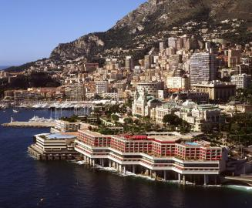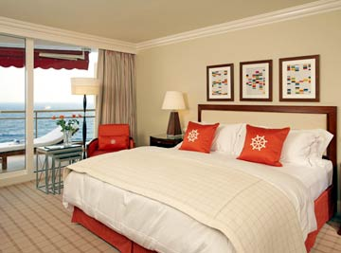

MUST – SEES :
Place du Palais :

The Place du Palais, Monaco's cultural heart, leads onto the imposing Prince's Palace and the delightful, historic charms of Monaco-Ville. Views from this enormous square stretch over both of Monaco's glitzy ports, all of its tall buildings and over to neighbouring Italy and France, making it a great point to orientate oneself from.
The main attraction starts every day at 11h55 sharp with the changing of the guard ceremony.
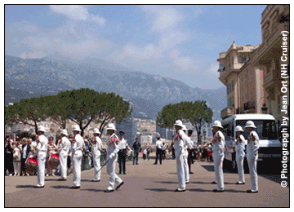

Prince’s Palace :
Taking up one whole side of the Place du Palais, the Prince's Palace is one of the oldest buildings in Monaco.
On display are several salons bathed in antiques, ancient portraits and gold. The throne room is a picture of elegance itself with a mosaic floor, period furniture and a frescoed ceiling. The main courtyard, with its splendid marble double staircase, hosts several open-air concerts each summer.
Prince's Palace. Place du Palais. Open: daily 09h00-18h00 (Apr-Oct); closed Nov-Mar. Admission: EUR7, adults; EUR3.50, children.

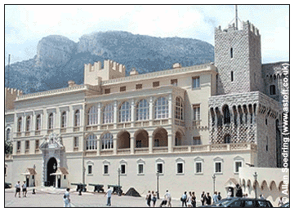

Monaco – Ville :
The red tiled roofs of the quiet Monaco-Ville cover the principality's historical quarter: a far cry from the high rise apartments and floating palaces that cover the rest of the city-state. The narrow, colourful streets have been beautifully maintained but in such a way as not to alter the wonderful character of the area.
Chapels, tiny squares and scores of lookout points stud the old town from the Place du Palais to the Avenue Saint Martin. Rue Basse is the most touristy of the little lanes with its Ferrari store, T-shirt stalls and handful of restaurants. Most charming is Rue Emile de Loth, which contains boutiques, bars and an excellent creperie.
In the area are the Oceanographic Museum, the Saint-Martin Gardens and the imposing cathedral.
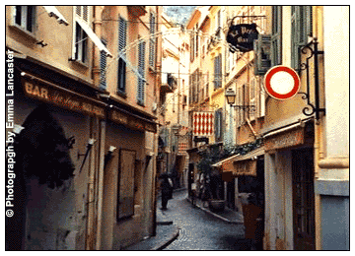

Monaco Cathedral :
Facing out towards Fontvieille on the west side of Monaco-Ville is the principality's cathedral.
The bright white stone of this awesome building was dug in the hill village of La Turbie, just above Monaco. Since 1875 it has served as a chapel (Grace Kelly and Prince Rainier married here) and cemetery for the ruling Grimaldi family. The high domed interior features a fresco by Niçois painter Louis Bréa. Mass is sung every Sunday at 10h00, from September to June.

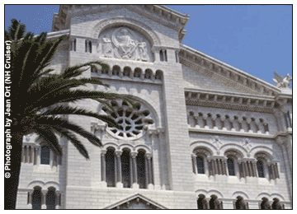

EXCURSIONS :
Nice :
Just down the coast from Monaco, Nice is as stylish and attractive as you would expect from the top city of the French Riviera.
The palm-fringed Promenade des Anglais that trails the coastline is where the city's beautiful people come to pose and is the ideal place for a leisurely stroll before dinner - or before hitting the beach. The beach, though pebbly, is of course the main draw for many visitors and is unlikely to disappoint. Nice does have various distractions away from the coast, though, including some fine art galleries, one each devoted to Matisse and Chagall plus the Modern and Contemporary Art Museum displaying works by Andy Warhol and Yves Klein among others

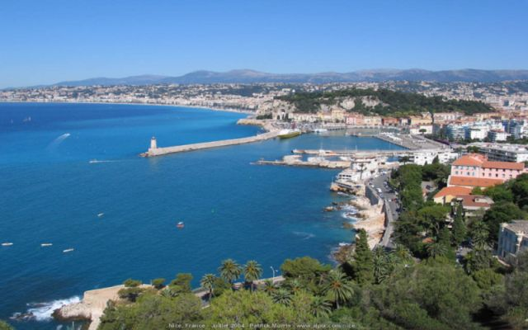

Cannes :
A little further along the coast from Nice, Cannes is noted for its irresistible dollops of glitz.
Famous for its year-round programme of arts festivals the best known of its events is of course the Cannes film festival when the ever-present sprinkling of stars that you find here at any time of year is swelled to saturation point. Visit at another time and you'll find Cannes a pleasant, if slightly snooty, coastal town, with miles of sandy beaches.
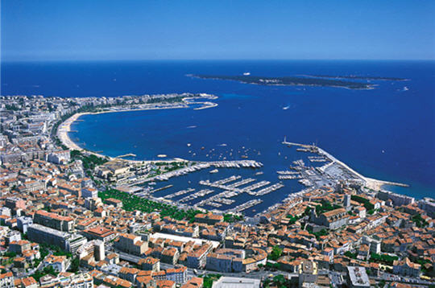

San Remo :
Travelling east of Monaco will take you across the border to the Italian stretch of the Riviera, on the whole not as glamorous as its French counterpart, but attractive nonetheless.
San Remo is the main town before you reach Genoa. One of the most stylish places in Europe in the late 19th and early 20th century, the city is still famed for its casino and glitzy nightlife, and is in many ways the Italian version of Monte Carlo. Away from the card tables, the city's most enticing area is the old quarter, known as La Pigna, or "pine cone", where you can lose yourself for several hours in the warren of tiny winding streets and cobbled alleyways.

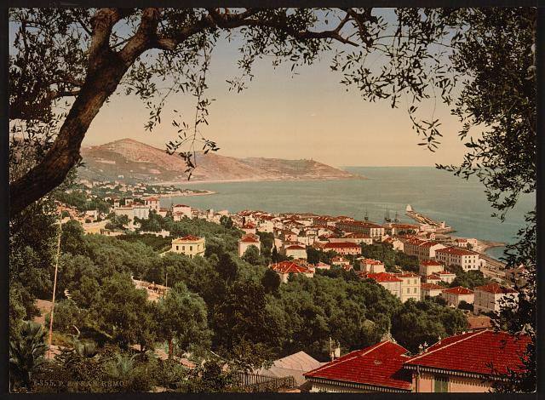

Azur Express :
Passengers are pulled around the historic streets of Monaco on this little tourist "train" (an electric truck on four wheels if truth be told). The route takes in the palace, the Casino and the old town on Monaco-Ville rock before heading back to its start point at the Oceanographic Museum. Commentary is in English, German, Italian and French. The journey takes 30 minutes. Open: 10h00-17h00 Oct-mid-Nov and Feb-Apr; 10h00-18h00 May-Sep. Admission: EUR6; free for children under 5. Trains do not run when it is raining. Starts at the Oceanographic Museum.

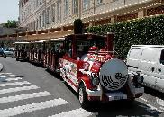

FOOD :
INDIAN RESTAURANTS :
New Indian
9, bd de la République, Monte Carlo, Monaco 06240
Tel : 334-93-78-17-89

Bombay Palace
30, COURS LUNEL, Nice 06300
Tel : 04 9356 1220

Raja Le
2, boulevard Carnot 06300, Nice
Tel : 04 9389 5736

Shalimar Le
29, Rue Jean Jaurès, Nice
Tel : 04 9338 4262

SHOPPING :
In the area immediately around the casino, the streets are alive with glitzy jewellers, haute couture tailors and expensive shoe shops. Within one hundred metres west around the Banca di Roma are Sonia Rykiel, Gianfranco Ferre, Prada and a host of other top name fashion designers.
Rue Grimaldi contains the more mainstream of the likes of designer Diesel together with a Formula One store and plenty of highbrow souvenirs. The pedestrianised Rue Princesse Caroline leading off Rue Grimaldi has a high street feel with less expensive shoe shops, fashion outlets and cafés.
The classiest indoor shopping centre in Monaco is the Metropole on the Place du Casino with its chandeliers and marble floor. Alfred Dunhill, Kenzo and FNAC all maintain outlets here. More down to earth, but great for a visitor's everyday needs, is the Centre Commercial in Fontvieille, which contains food store Carrefour and sports shop Decathlon. The antique-laden Marché de la Brocante around the Fontvieille port takes place every Saturday from 09h30 until 17h00. Most of the display is quite classy with plenty of jewellery, household goods and objets d'art for sale.

